Name: Hamna Mahmood  
Roll Number: 25   
BSE V-A

LAB 5 Markdown file  
**CLOUD COMPUTING**  
  
****  
  
**SUBMITTED TO**   
SIR WAQAS SALEEM  
  
**SUBMITTED BY**   
HAMNA MAHMOOD   
2023-BSE-025  
  
BSE V-A  
  
**Lab 5**  
  
**Lab Title**  
  
**Java, apt vs apt-get, snap, GUI, Vim on Ubuntu Server**  
  
**Task 1 - Discover missing command & install Java using apt suggestion**  
  
task1_java_suggestion.png  
  
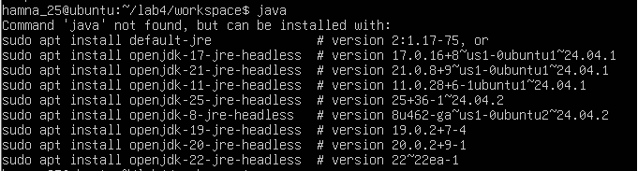  
  
task1_java_install.png  
  
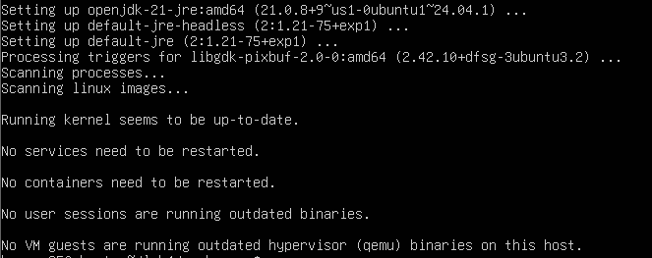  
  
task1_java_version.png  
  
  
  
task1_java_remove.png  
  
**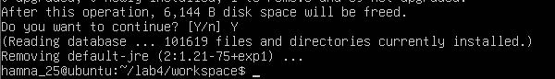**  
  
task1_java_not_found.png  
  
**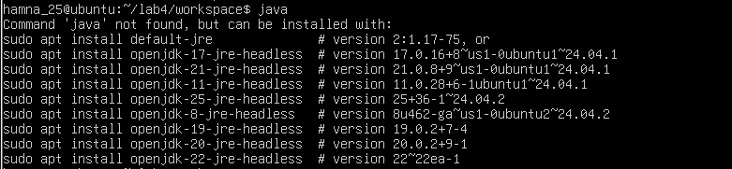**  
  
task1_hash_clear.png  
  
****  
  
**Task 2 - Install & remove Java using apt-get (explicitly)**  
  
task2_aptget_install.png  
  
**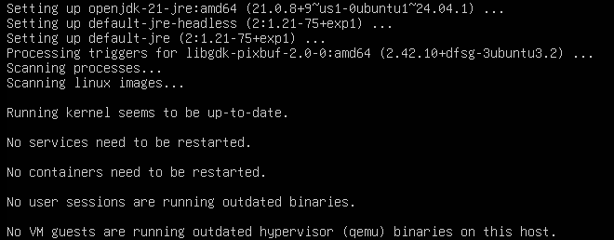**  
  
task2_java_version_after_aptget.png  
  
  
  
task2_aptget_remove.png  
  
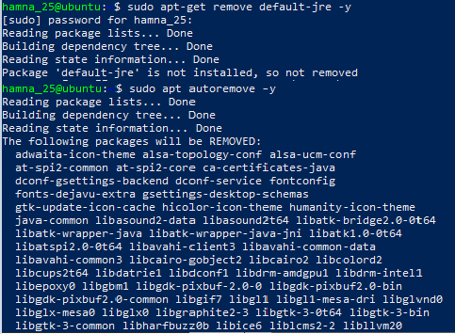  
  
task2_hash_after_remove.png  
  
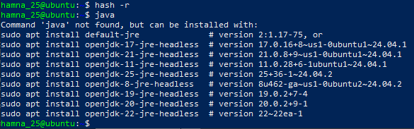  
  
**Task 3 - apt update vs apt upgrade - run & explain**  
  
task3_apt_update.png  
  
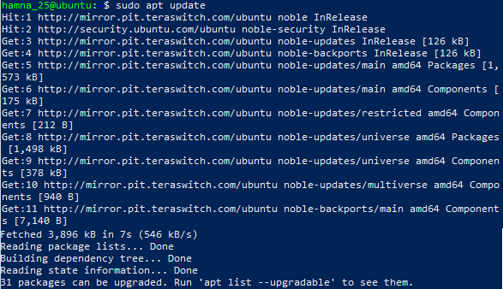  
  
task3_apt_upgrade.png  
  
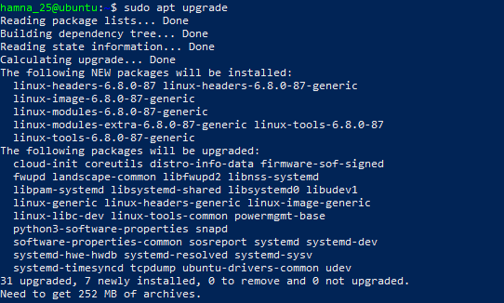  
  
task3_explanation.png  
  
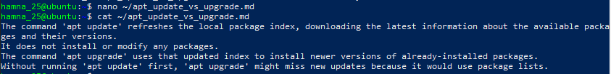  
  
**Task 4 - Install Visual Studio Code via snap on CLI and verify (DO NOT remove Code)**  
  
task4_snap_install.png  
  
  
  
task4_snap_list.png  
  
  
  
task4_code_version_or_info.png  
  
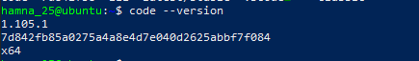  
  
task4_snap_bin_location.png  
  
  
  
**Task 5 - Install XFCE GUI + XRDP - minimal desktop and remote access (GUI) and launch VS Code**  
  
task5_update.png  
  
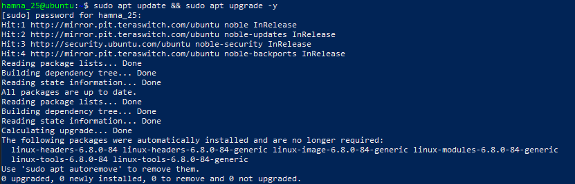  
  
task5_xfce_install.png  
  
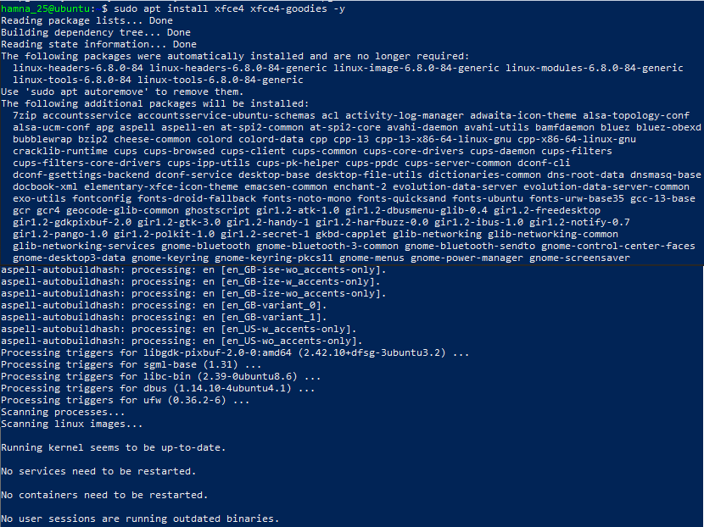  
  
task5_xrdp_enable.png  
  
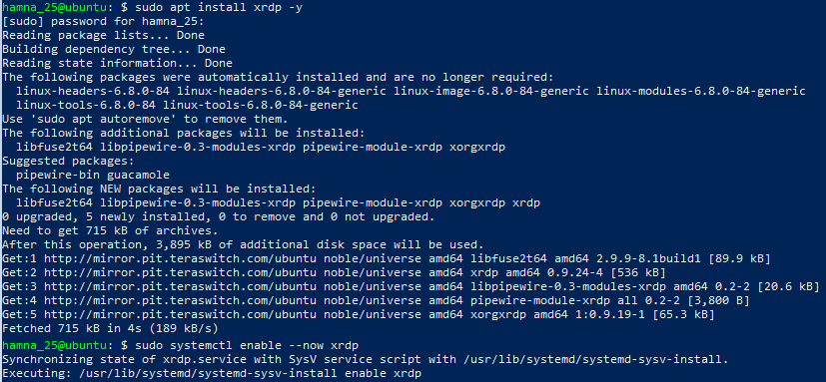  
  
task5_xrdp_status.png  
  
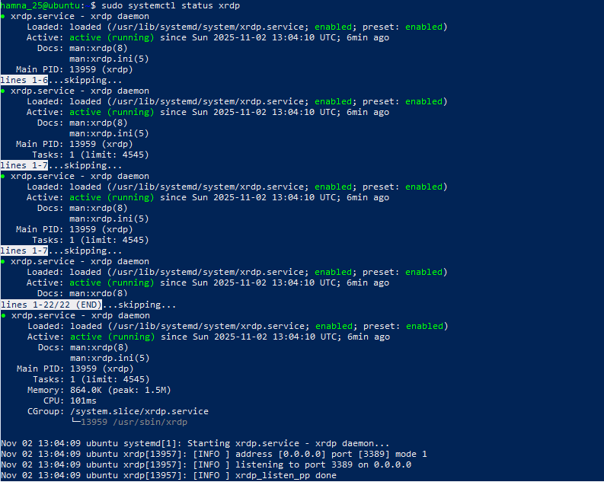  
  
task5_xsession.png  
  
  
  
task5_rdp_connect.png  
  
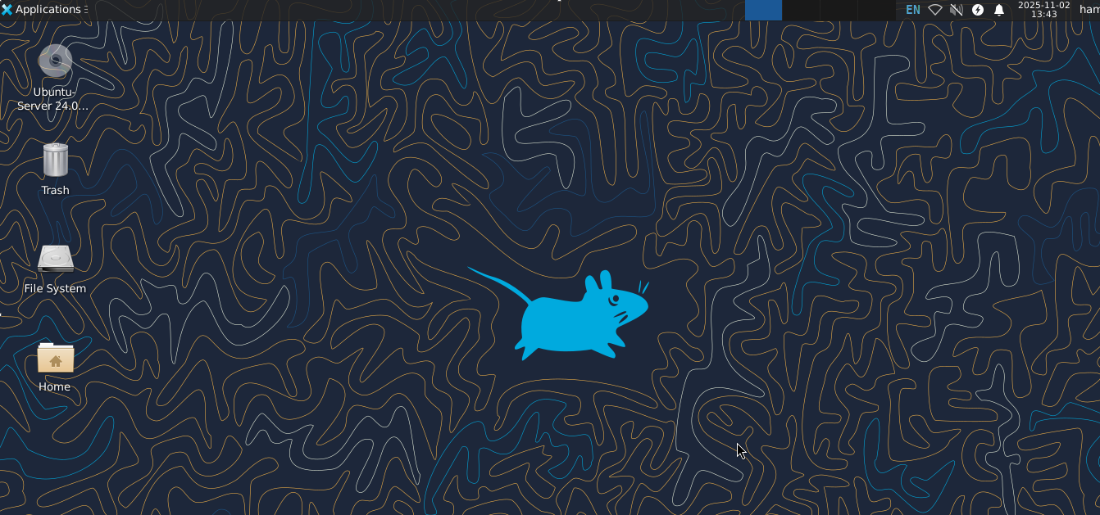  
  
task5_vscode_launch.png  
  
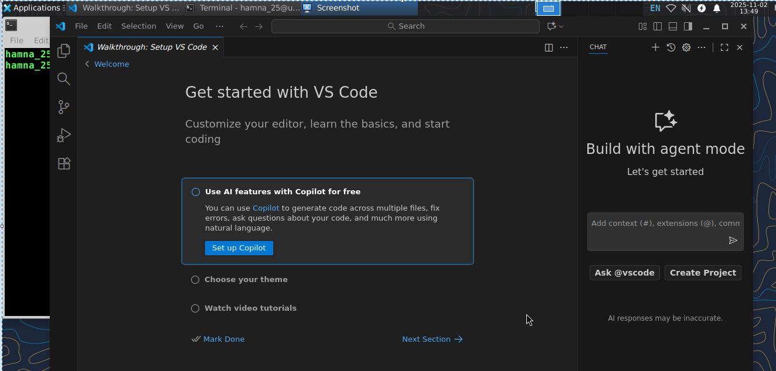  
  
**Task 6 - Install lightdm-gtk-greeter and GUI verification - start GUI, open VS Code, take snapshot, then end (GUI)**  
  
task6_lightdm_install.png  
  
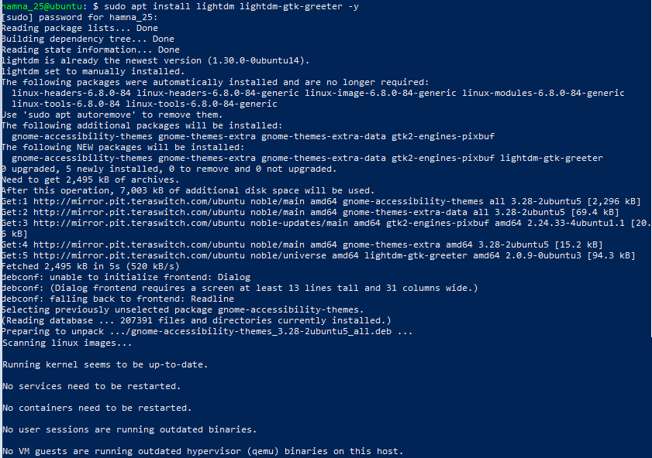  
  
task6_lightdm_config.png  
  
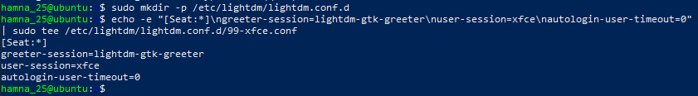  
  
task6_lightdm_cleanup.png  
  
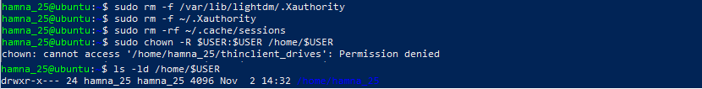  
  
task6_lightdm_restart.png  
  
  
  
task6_gui_enable_boot.png  
  
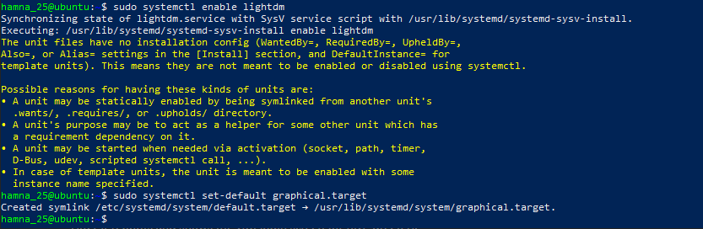  
  
task6_after_reboot_gui.png  
  
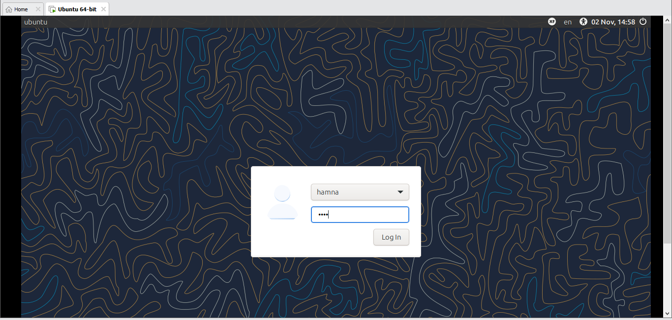  
  
task6_gui_disable_boot.png  
  
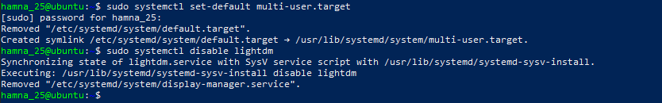  
  
task6_after_reboot_cli.png  
  
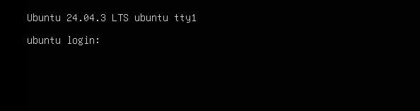  
  
task6_gui_start.png  
  
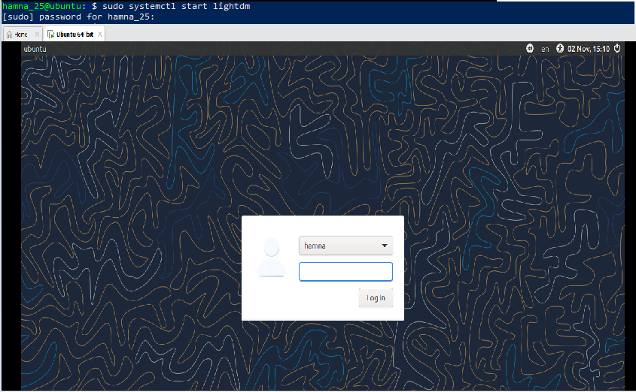  
  
task6_gui_stop.png  
  
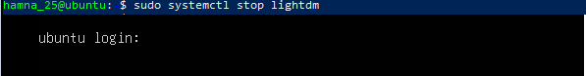  
  
task6_gui_start_command.png  
  
  
  
task6_vscode_launch.png  
  
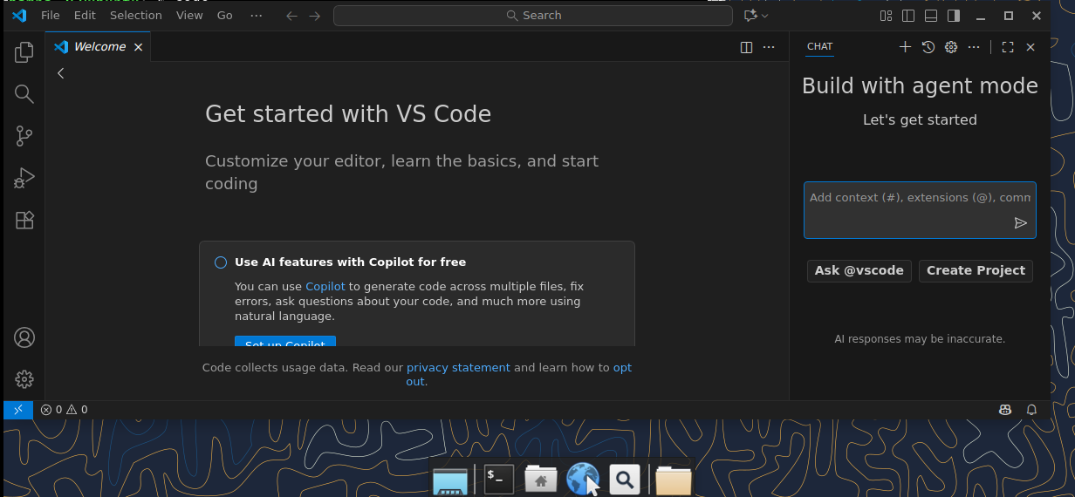  
  
**Task 7 - Install Google Chrome by adding its apt source & key (Chrome)**  
  
task7_install_chrome_error.png  
  
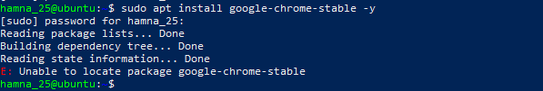  
  
task7_ls_etc_apt.png  
  
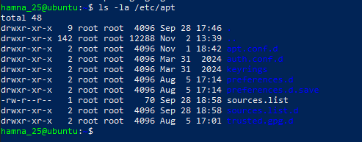  
  
task7_cat_sources_list.png  
  
  
  
task7_ls_sources_list_d.png  
  
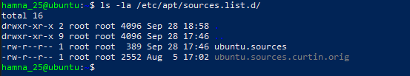  
  
task7_cat_ubuntu_sources.png  
  
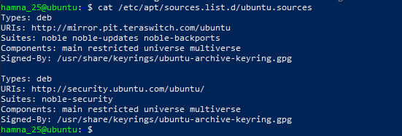  
  
task7_edit_ubuntu_sources.png  
  
  
  
task7_add_key.png  
  
  
  
task7_apt_update.png  
  
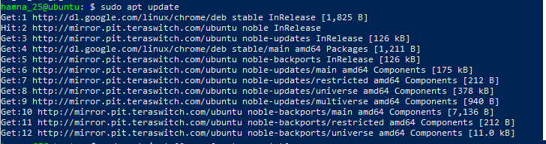  
  
task7_install_chrome.png  
  
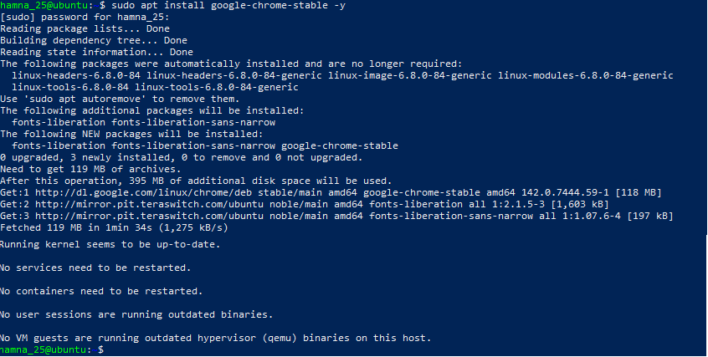  
  
task7_alternate_remove.png  
  
Here, in the file, links other than the official ubuntu link of <http://archive.ubuntu.com/ubuntu/> was deleted.  
  
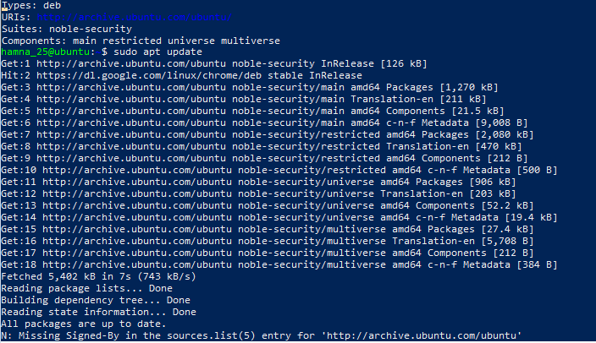  
  
task7_alternate_edit.png  
  
Here, the link was edited from <http://security.ubuntu.com/ubuntu/> to <http://archive.ubuntu.com/ubuntu/>  
  
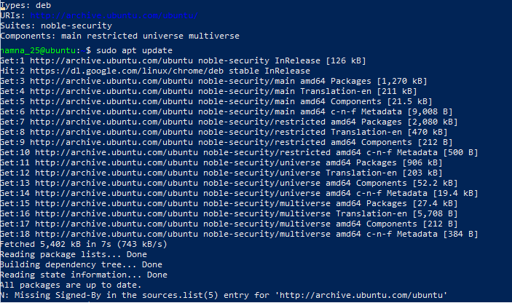  
  
task7_remove_key.png  
  
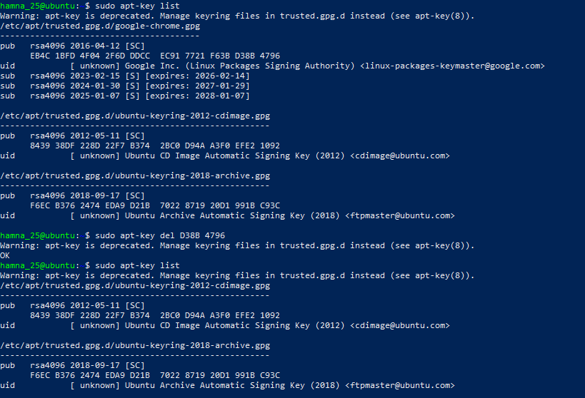  
  
task7_create_google_chrome_list.png  
  
  
  
task7_list_sources_after_create.png  
  
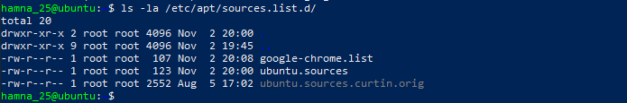  
  
task7_add_key_alt.png  
  
  
  
task7_apt_update_alt.png  
  
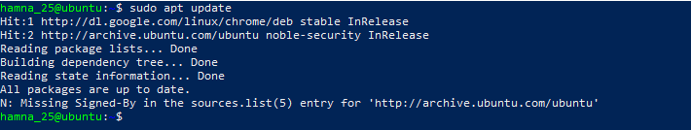  
  
task7_install_chrome_alt.png  
  
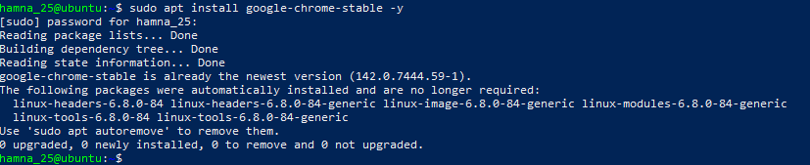  
  
**Task 8 - Install applications via PPA (Audacity & OBS) and launch**  
  
task8_add_ppa_audacity.png (running within XFCE terminal)  
  
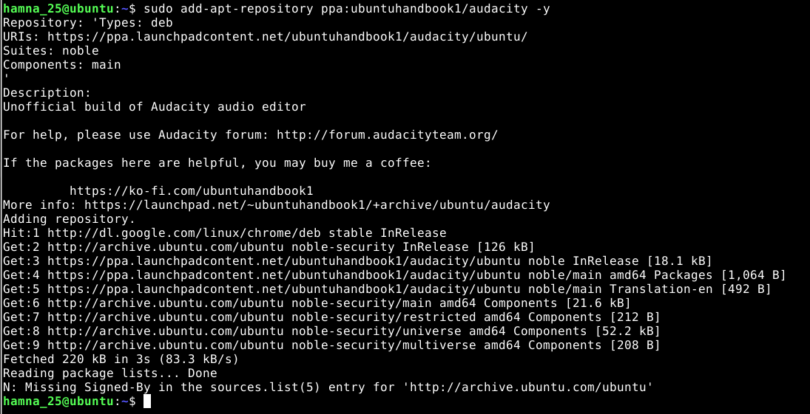  
  
task8_apt_update_audacity.png  
  
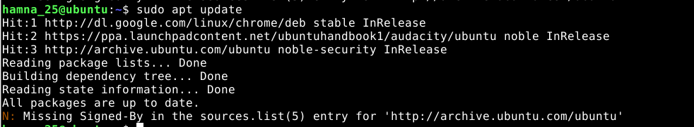task8_install_audacity.png  
  
  
  
task8_audacity_launch.png (GUI launch screenshot if possible) or task8_audacity_version.png (CLI verification)  
  
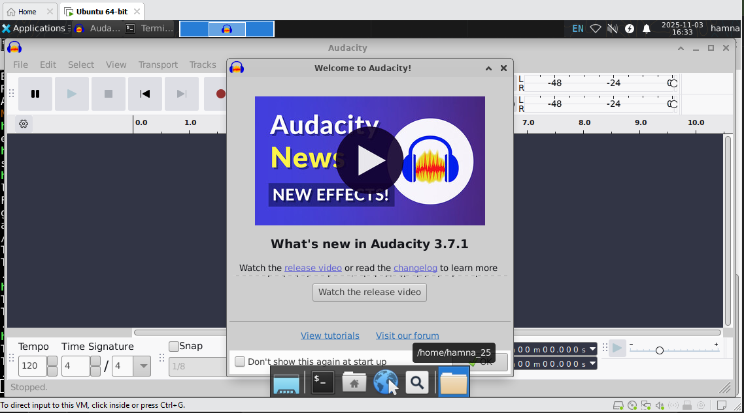  
  
task8_add_ppa_obs.png (output of add-apt-repository)  
  
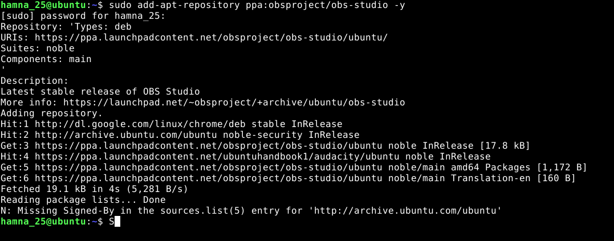  
  
task8_apt_update_obs.png (apt update after adding PPA)  
  
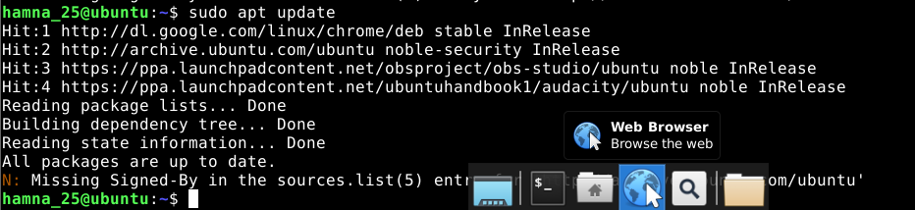  
  
task8_install_obs.png (apt install output)  
  
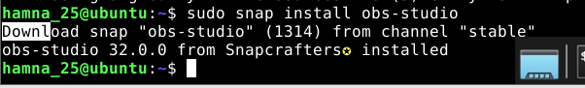  
  
task8_obs_launch.png (GUI launch screenshot if possible) or task8_obs_version.png (CLI verification)  
  
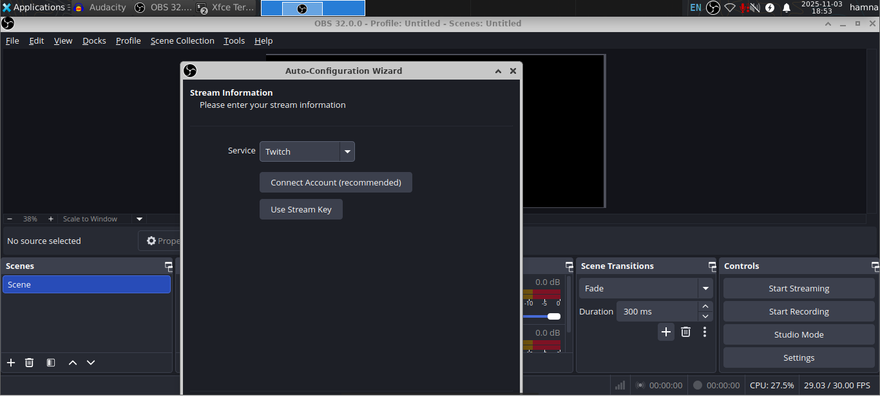  
  
**Task 9 - Create a Kubernetes sample YAML using vim**  
  
task9_vim_check.png  
  
  
  
task9_vim_install.png (only if you installed it).  
  
_Mine is already installed_  
  
task9_mkdir_cd.png  
  
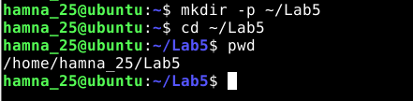  
  
task9_vim_edit.png  
  
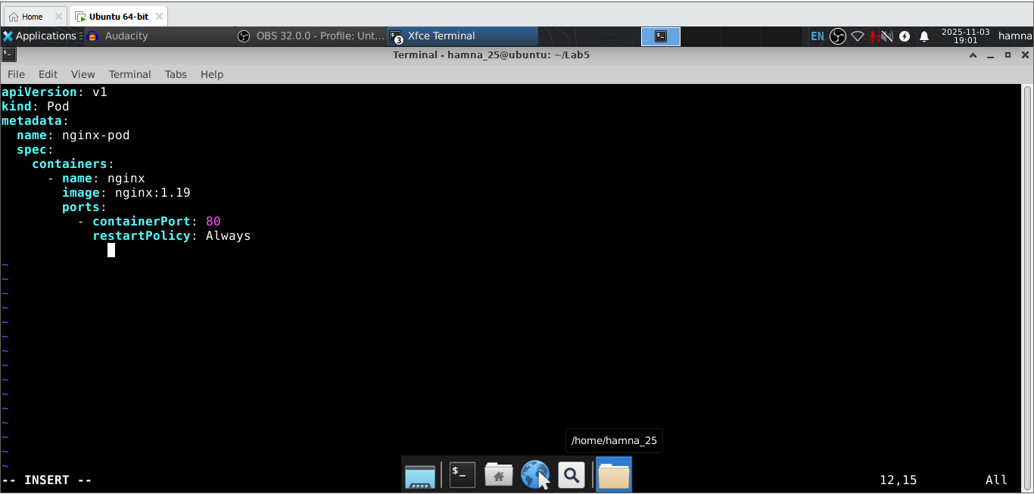  
  
task9_k8s_saved.png  
  
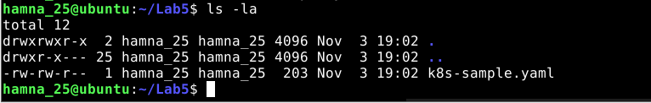  
  
**Task 10 - Edit the Kubernetes YAML - add annotation, verify, then discard temporary change**  
  
task10_verify_annotation.png  
  
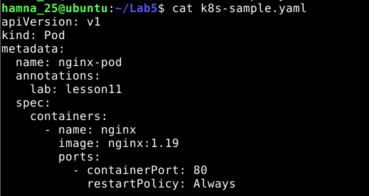  
  
task10_verify_entering_temp_data.png  
  
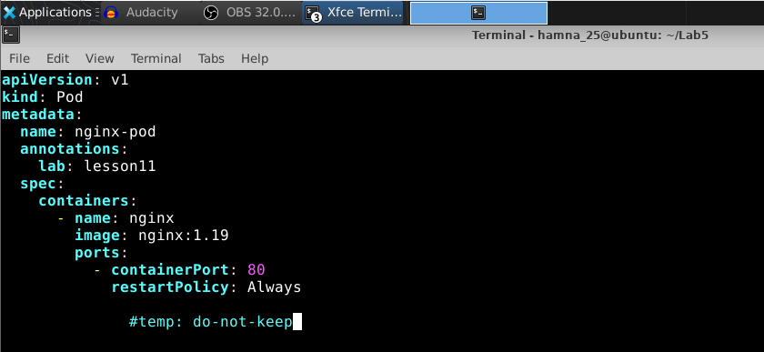  
  
task10_verify_no_temp_comment.png  
  
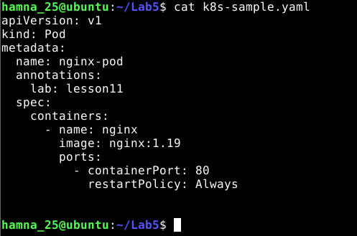  
  
**Task 11 - Vim editing practice - delete, undo, numeric deletes, navigation**  
  
task11_dd_delete_and_undo.png   
_Both images are shown together (before and after)_  
  
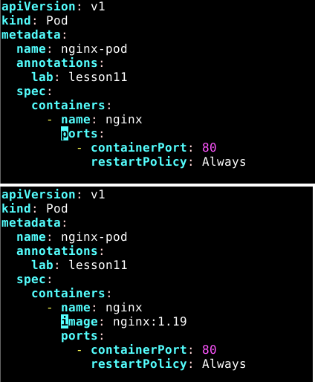  
  
task11_delete3_and_undo.png  
  
_Both images are shown together (before and after)_  
  
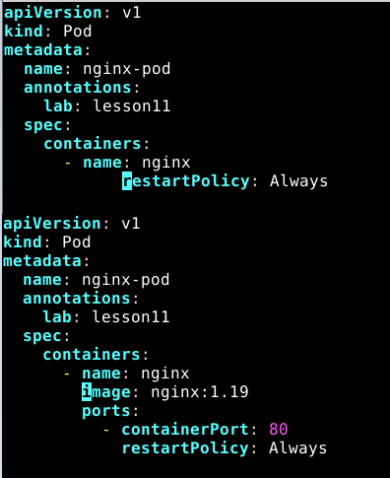  
  
task11_line1.png  
  
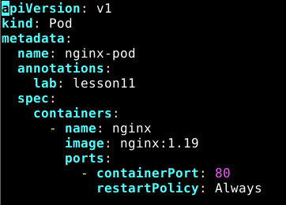  
  
task11_navigation.png  
  
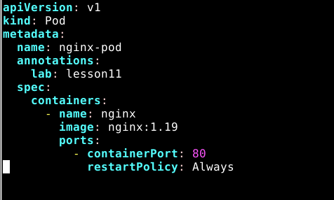  
  
**Task 12 - Vim search, add matches, substitute, undo**  
  
task12_search_nginx.png  
  
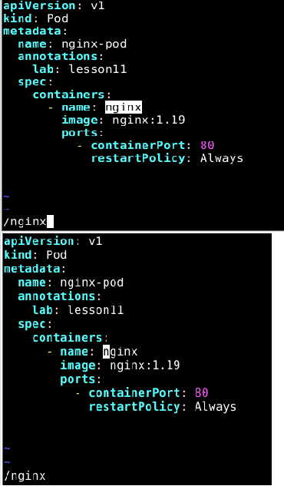  
  
task12_n_and_N_navigation.png  
  
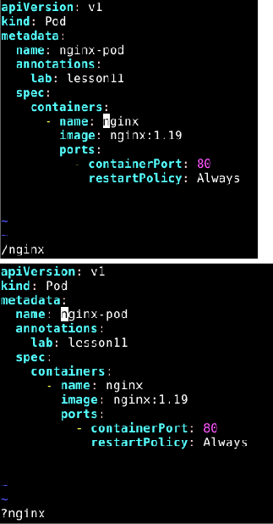  
  
task12_added_occurrences.png  
  
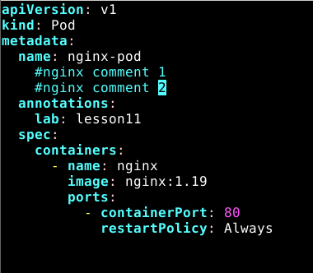  
  
task12_cycle_matches.png  
  
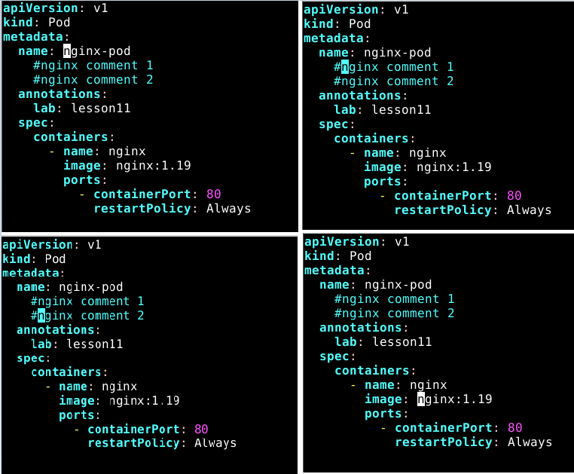  
  
task12_substitute_result.png  
  
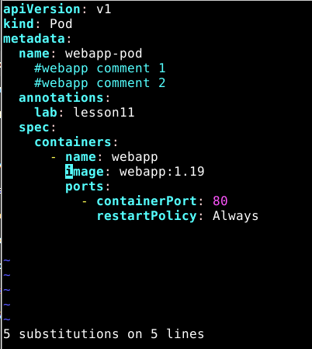   
  
task12_undo_and_quit.png  
  
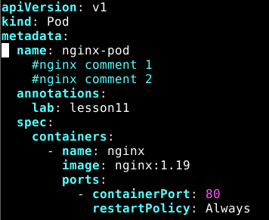  
  
**Exam Evaluation Question**  
  
- **Install Docker Desktop on your VMWare Workstation Ubuntu Server. No commands or solutions are provided in this lab - treat this as an evaluation/exam question.**  
  
**SOLUTION**  
  
First, updating system,  
  
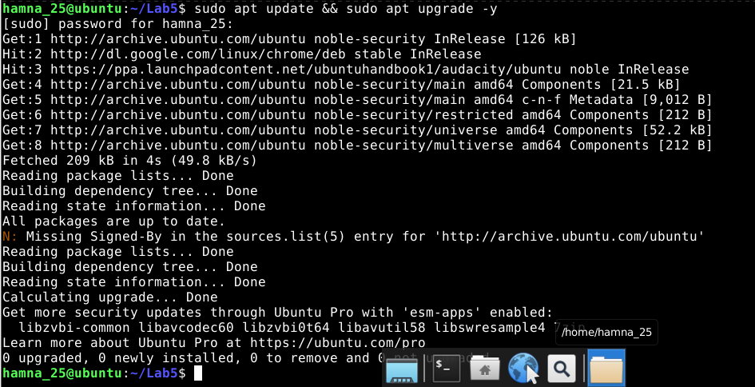  
  
Installing prerequisites,  
  
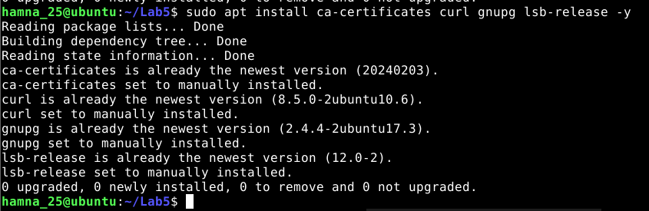  
  
Adding Docker's official GPG key,  
  
  
  
Adding the Docker repository,  
  
  
  
Updating apt again,  
  
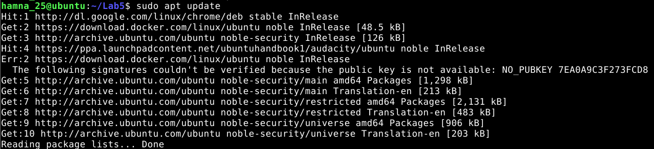  
  
Installing Docker Desktop,  
  
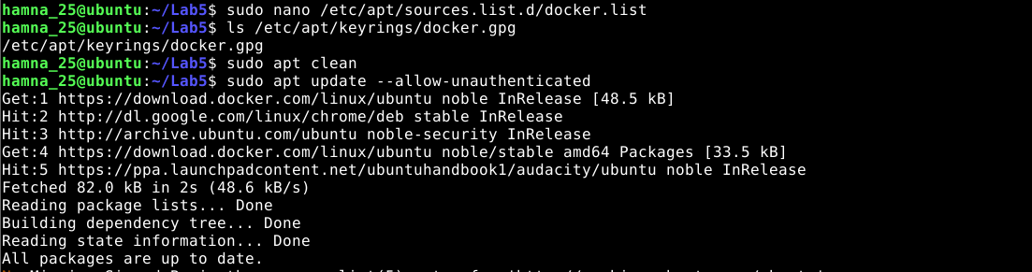  
  
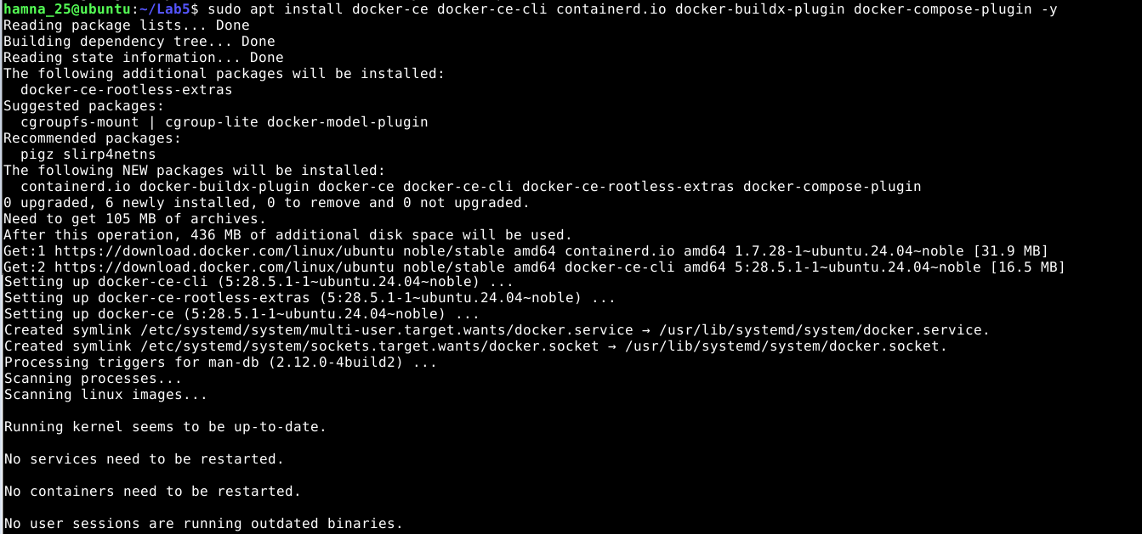  
  
Verify if installed or not,  
  
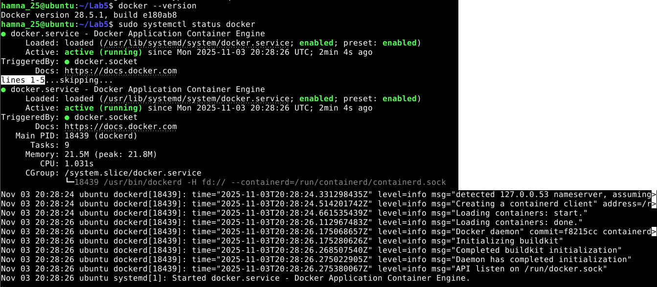  
  
- **Verify Docker Desktop is installed by launching the Docker Desktop application and confirming it runs.**  
  
Verified that Docker Engine was running with:  
  
docker version  
  
**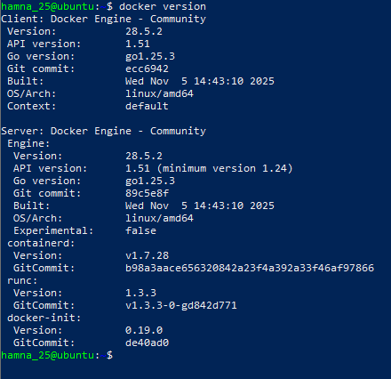**  
  
docker info  
  
**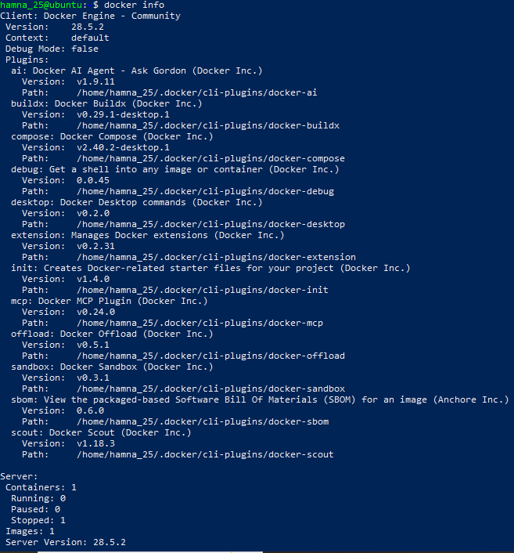**  
  
Installing GUI (XFCE) Environment  
  
Run this in your Ubuntu VM terminal: sudo apt update  
  
**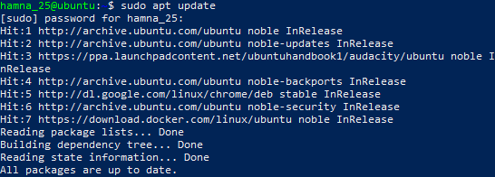**  
  
sudo apt install xfce4 xfce4-goodies -y  
  
**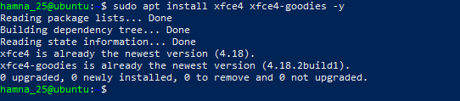**  
  
This installs the XFCE desktop and some useful components (lightweight, works well in VMware).   
It may take a few minutes.  
  
Verify or (Re)Enable XRDP for Remote GUI Access  
  
Now let's ensure you can actually open and _see_ the XFCE desktop GUI through VMware (or RDP if needed). Run this command next: sudo systemctl enable --now xrdp  
  
****  
  
Then check XRDP status: sudo systemctl status xrdp  
  
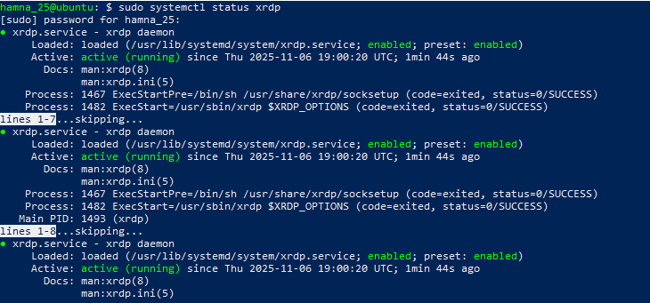  
  
Switch to GUI mode  
  
Run this command in your terminal: sudo systemctl set-default graphical.target  
  
sudo systemctl isolate graphical.target  
  
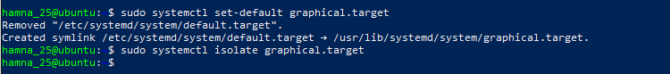  
  
Then, wait a few seconds - your screen should change to a **login window** (the XFCE GUI login).   
If it doesn't, you can reboot manually: sudo reboot  
  
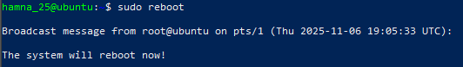  
  
**Started the GUI session manually when in CLI mode:**  
  
sudo systemctl start lightdm  
  
After this:  
  
In VMware, your VM will show a **login screen** (username/password prompt).  
  
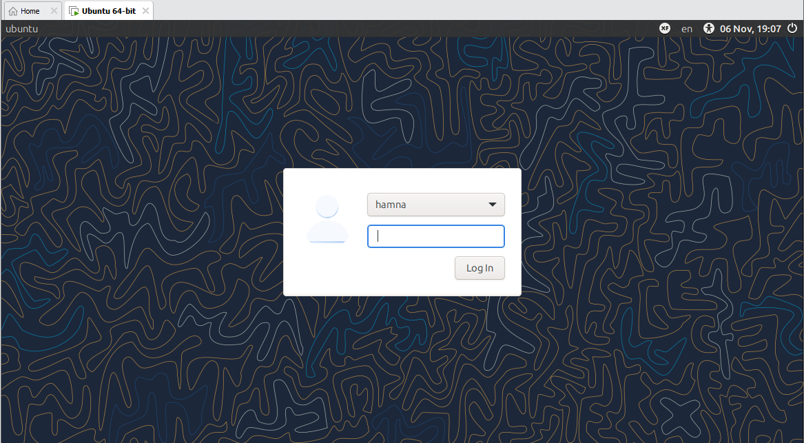  
  
First login.  
  
**Download the Docker Desktop .deb package**  
  
Now that you're inside XFCE: Click the **blue globe icon** (that's your web browser).  
  
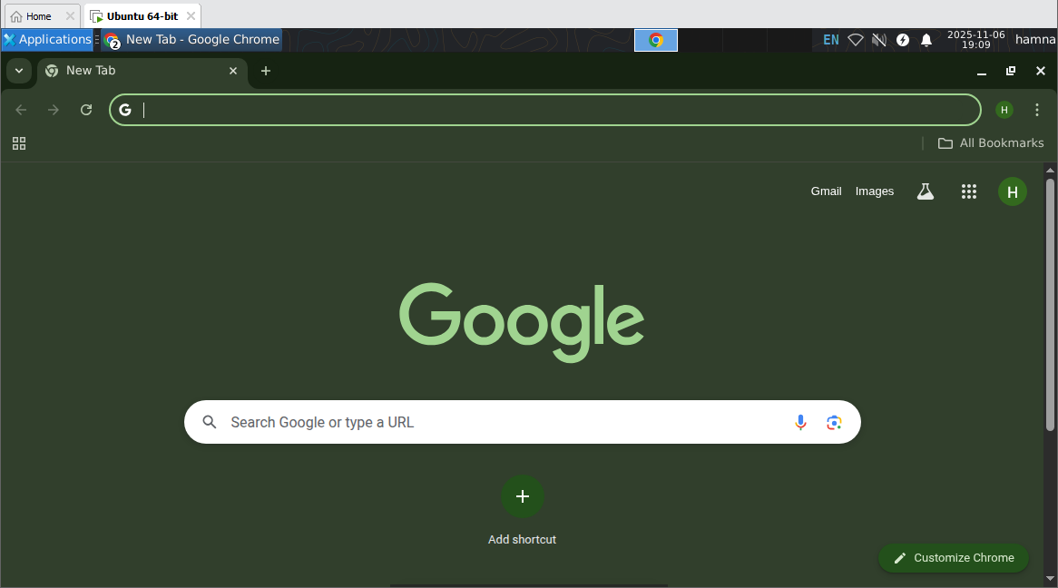  
  
In the browser, go to given link and this automatically download the file:   
[**https://desktop.docker.com/linux/main/amd64/docker-desktop-amd64.deb**](https://desktop.docker.com/linux/main/amd64/docker-desktop-amd64.deb)  
  
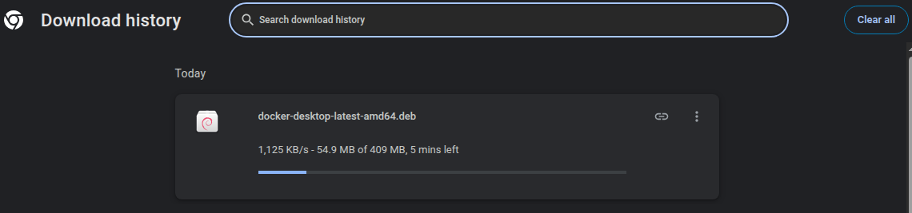  
  
**Install Docker Desktop**  
  
Run the following commands one by one **in your terminal** (you should still be in your home directory ~):  
  
cd ~/Downloads  
  
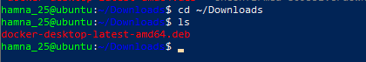  
  
Then install it using:  
  
sudo apt install ./docker-desktop-amd64.deb -y  
  
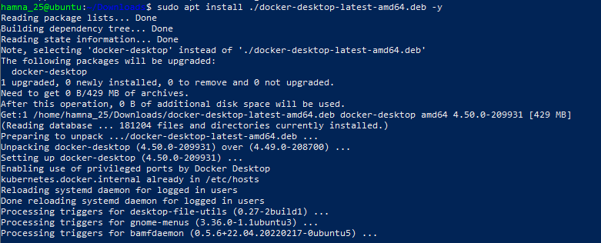  
  
In your **Ubuntu GUI** (XFCE desktop), click the **Applications menu** (usually at the top-left or bottom-left corner).  
  
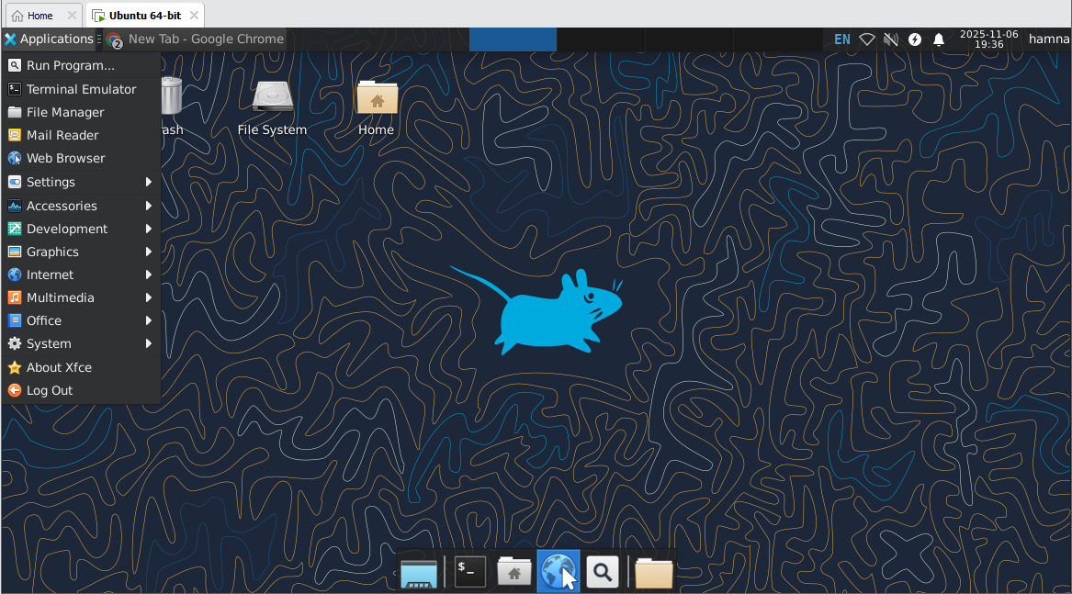  
  
Type **Docker Desktop** in the search bar.  
  
Click on **Docker Desktop** to launch it.  
  
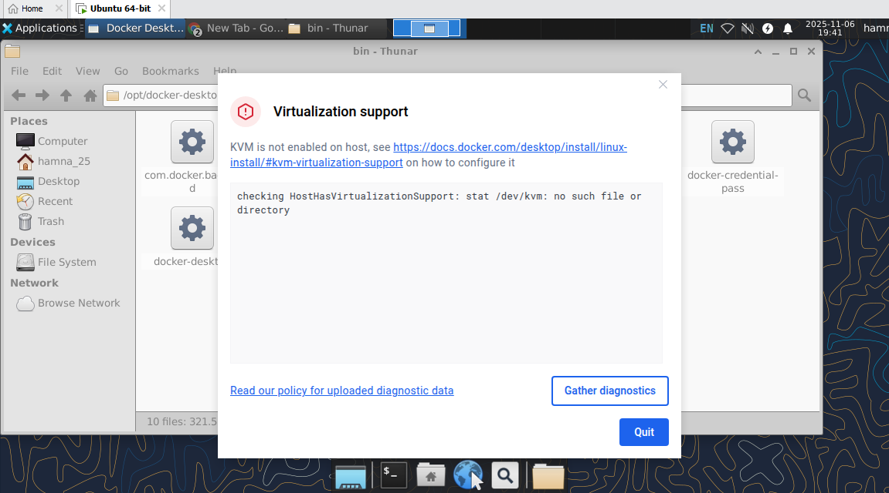 Virtualization Error.  
  
**Solution:**  
  
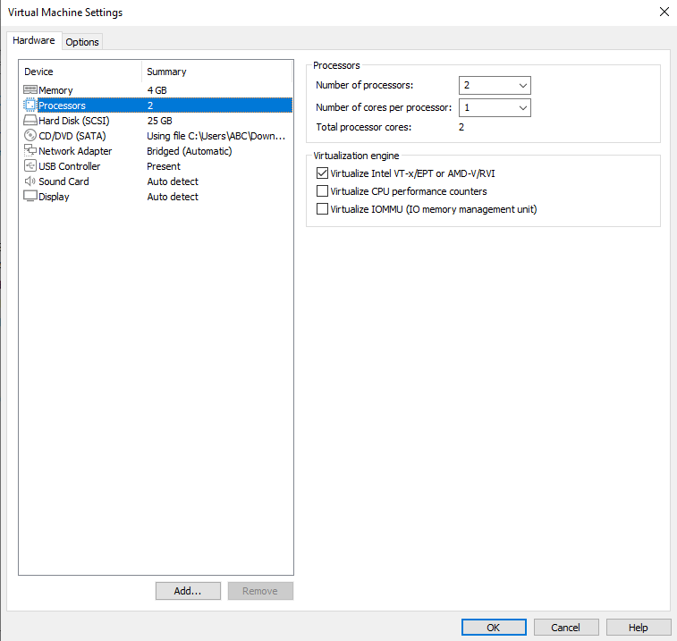  
  
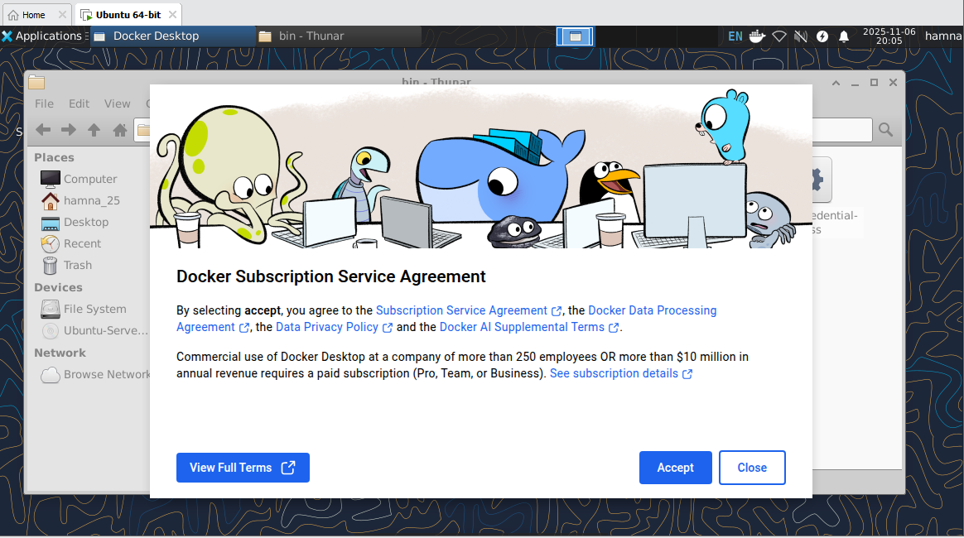  
  
Then wait a bit while Docker Desktop starts up (it might take 30-60 seconds).  
  
Once you see the Docker whale 🐳 icon or the main Docker Desktop window, that means it's running.  
  
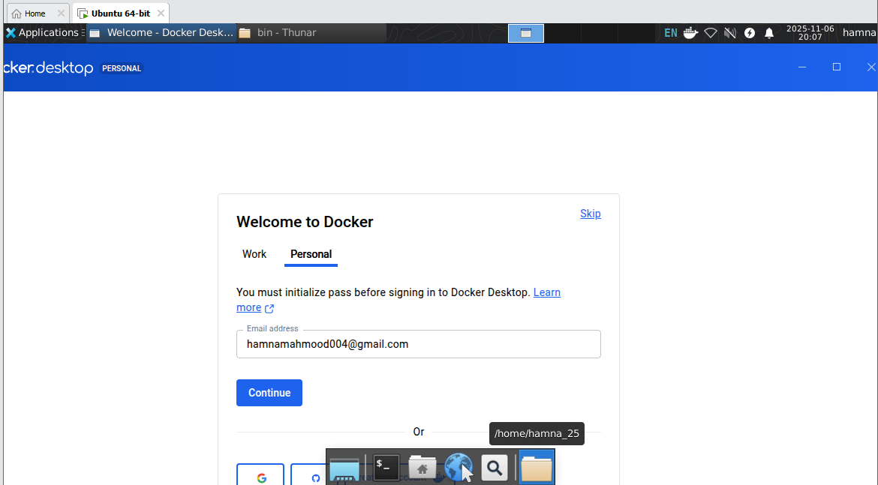  
  
- **Capture a screenshot of Docker Desktop running (or other clear evidence that Docker Desktop is installed and started) and save it as: exam_evaluation_docker_desktop.png**  
  
